# Brand Guide

**Files to download -** [**Media Kit**](https://drive.google.com/drive/folders/1hXs59YlgV6be8Z29Q-cNnEU5j-TMTISR?usp=sharing)

## Logo

|  | Main version | Secondary Version |
| --- | --- | --- |
|  | Preferred color | Used on red background and similar |
| For monotonous background  Video-photo watermark  Navbar logo |  |  |
| For not monotonous background  Video-photo watermark  Navbar logo |  |  |
| For monotonous background  Press Wall  Partners websites |  |  |
|  |  |  |
|  |  |  |
|  |  |  |

## Colors

| **Color values** | **Red** | **Black** |
| --- | --- | --- |
| RGB | 230, 13, 46 | 34, 34, 34 |
| HEX | #E60D2E | #222222 |
| CMYK | 1, 100, 76, 6 | 60, 40, 40, 100 |
| Pantone | 199C | Black C |
| RAL | 3020 | 9005 |

**Logo placement on images**

## Photography

### Photos of mech products

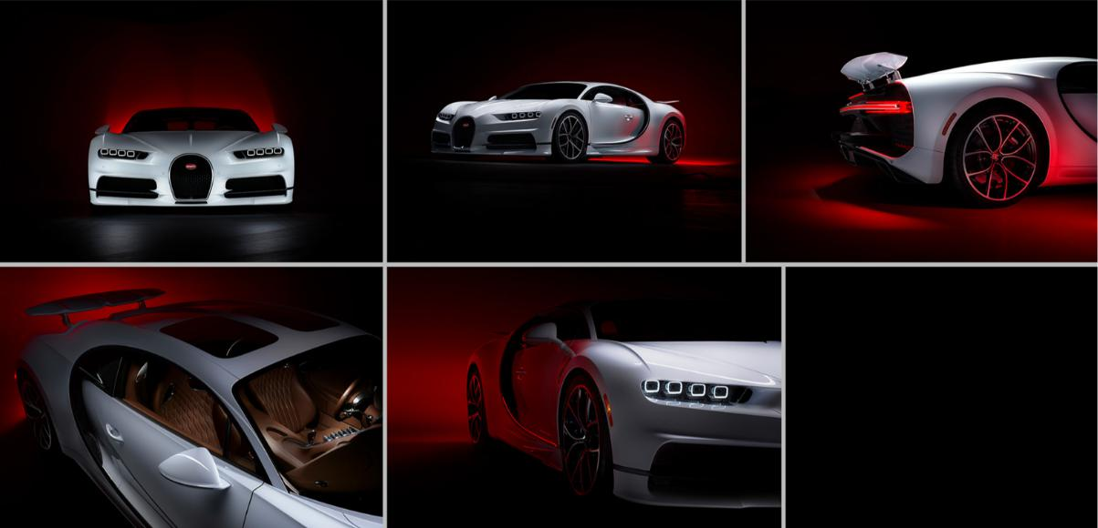

**Example of bad photo** - Red is appeared as a faded pink - this should be avoided

### 

### Photos of people example

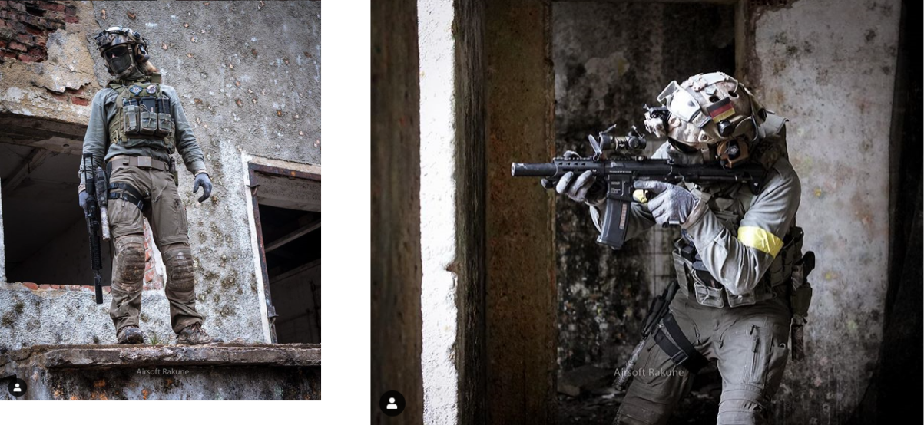

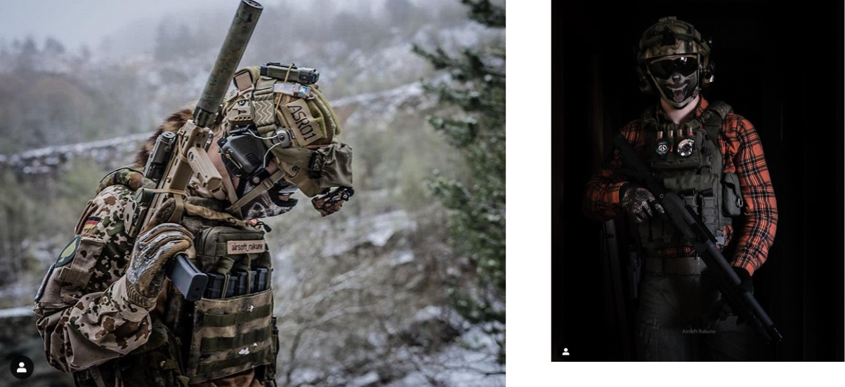

GFX

## 

